e

***Introduction to Wireless Network***

Electrical Engineering, National Taiwan University

5G Mobile Handoff Simulator

陳守仁 b09901116白宗民 B09602017

***無線網路導論***

5G Mobile Handoff Simulator

陳守仁 B09901116

白宗民 B09602017

Electrical Engineering, National Taiwan Universiy

*Abstract —* Cellular deployments have relied on network-centric control over resource management and capacity allocation. Machine learning techniques, in particular, have embraced this centralized approach, leveraging the computational capabilities and contextual information available at the network core. However, as the trend towards network decentralization gains traction, the effectiveness of models built on assumptions of consistent network performance and information availability may diminish. This paper proposes a novel perspective on resource management, shifting the paradigm towards client-centric execution of a learning algorithm. In this approach, the client device itself takes charge of its mobility and resource allocation, operating in scenarios where networks and their associated data are not centrally managed. By empowering client devices with autonomous learning capabilities, this alternative viewpoint aims to address the challenges posed by network decentralization and enhance resource management in dynamic environments.

# Introduction

The advent of 5G has revolutionized the flexibility in configuring and delivering cellular services through network softwares. Unlike the traditional MVNO agreements and overlay networks prevalent in the 4G era, 5G empowers virtualization and dynamic functionality across the entire network. This shift mirrors the transformative impact of cloud computing, where software advancements have facilitated the separation of hardware and software, enabling slower hardware generations to become more versatile and capable of accommodating diverse software and services. Consequently, this decoupling presents an exciting possibility: the complete disaggregation of network infrastructure, paving the way for the creation of entirely new service formats by seamlessly combining multiple Amazon Web Services, not only for 5G but also for future generations like 6G and beyond.

SDN (Software Defined Networking) technologies, which were originally designed to decouple data and control planes for backbone network flows, are now being increasingly adapted for wireless networks. This includes recent research focusing on adversarial dynamic spectrum access and software radio, enabling infrastructure slicing all the way to the radio access edge.

However, achieving full decentralization faces challenges due to the classic resource management structures that maintain global visibility at the base station and cellular core, while relying on a subordinate UE (User Equipment) device at the network edge. This raises questions about the role of the UE device and how network services are consumed in the absence of traditional network control. Since the UE device has limited environmental context, addressing device control in such scenarios requires further research.

We  aim to enhance the existing mobile-controlled handoff capabilities by utilizing the RSSI (Received Signal Strength Indicator) measurement. Firstly, we provide background information on cellular mobility mechanics, recent research on cellular network decentralization, and potential machine learning approaches that could serve as alternatives to the method proposed in this paper. Next, we present our design of a "soft handoff and hard handoff" algorithm in section three, followed by the simulation results in section four. Finally, the report concludes with a discussion of the findings and outlines potential avenues for future research in section five.

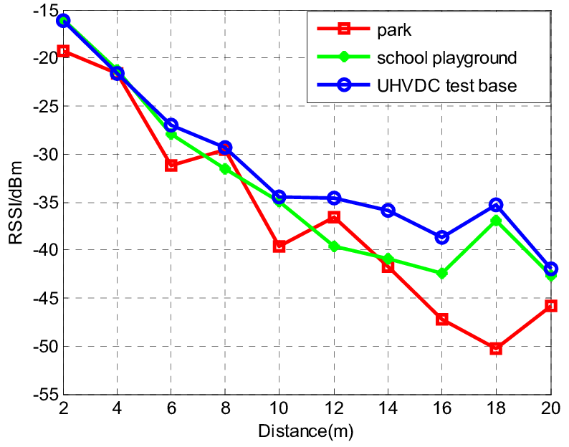

Figure 1: Example of RSSI measurement from the mobile

# Background and Research

## Mobile Handoff Management

Mobile handoff can be broadly categorized into network-controlled handoff, mobile-assisted handoff, and mobile-controlled handoff.

Network-controlled handoff depends on centralized control, where base stations will make the handoff decisions based on network conditions. In network-controlled handoff, soft handoff and hard handoff decided by the base station is implemented. Hard handoff occurs when the base station completely disconnects with the mobile station once it leaves its range or when it enters the other base station’s range. On the other hand, soft handoff is when it will continue to connect to the mobile station until another base station connects to it. Mostly in this case, delay would be a big problem, which decreases the quality.

Mobile-assisted handoff involves the mobile device providing sensor readings to the core network, enabling more informed handoff decisions. Mobile-controlled handoff empowers the mobile device to initiate handoff decisions based on received signal strength indicators (RSSI) from surrounding base stations. Some signal strength indicators are SINR and distance. This would be considered as more of a decentralized control where most mobile are able to make their own handoff decision based on where they stand.

Despite the advancements in handoff techniques, there are limitations that hinder their efficiency. Network-controlled handoff can introduce significant signaling latency due to central decision-making and dependence on remote network cores. Mobile-assisted handoff relies on periodic updates from the mobile device, which may not capture real-time changes in network conditions. While mobile-controlled handoff reduces handoff times, it may lack the contextual awareness to make optimal decisions in dynamic environments.

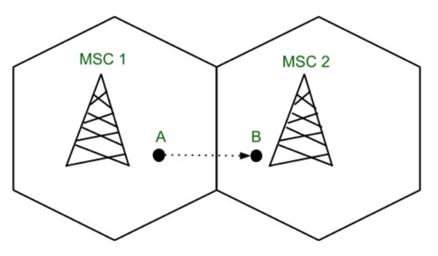

Figure 2: Hard Handoff

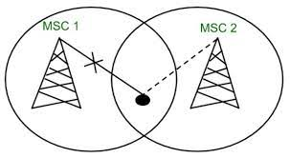

Figure 3: Soft Handoff

Figure 2.

## Advancing Handoff Efficiency through Algorithms:

To address the limitations of traditional handoff mechanisms, advanced algorithms leveraging machine learning and context-awareness can be employed. These algorithms aim to optimize handoff decisions by considering various factors, such as network conditions, device mobility patterns, and user preferences.

One approach involves the application of machine learning techniques, such as supervised, unsupervised, and reinforcement learning, to handoff decision-making. Supervised learning models can be trained with labeled data to accurately predict optimal handoff points based on historical patterns. Unsupervised learning enables the discovery of hidden structures in network data to enhance handoff decisions in the absence of labeled data. Reinforcement learning facilitates dynamic adaptation by mapping actions to situations, maximizing rewards based on observed outcomes.

1. Supervised Learning

Supervised Learning: In the realm of machine learning, supervised learning models excel at mapping the relationships between inputs and outputs. Guided by a "supervisor" signal in the form of labeled data, these models acquire the ability to generalize from the presented input-output mappings. The presence of labeled data grants control over the learning process, as the model can precisely grasp the patterns. By training supervised learning systems with high-quality, representative data that aligns with the ground truth, we can achieve remarkable accuracy even when confronted with unseen data points. Nevertheless, the dependency on labeled data and the careful control it demands can be considered a drawback of supervised learning. While supervised learning methods are less common in cellular deployment, it is found useful in areas such as mobile edge computing (MEC) and Quality of Service (QoS) policy control operations, particularly within the less resource-constrained network core.

1. Unsupervised Learning:

When acquiring labeled data becomes challenging or simply unavailable, unsupervised learning offers an alternative approach to uncover the hidden structures within datasets. In this methodology, the model relinquishes some control over what it learns in exchange for the ability to discover underlying patterns and make predictions without prior knowledge of the ground truth provided by labeled data. While unsupervised learning also relies on a large and diverse dataset, it encounters an additional challenge: assessing the accuracy of models derived from unlabeled data without human validation. Unlike supervised learning, where human effort is primarily concentrated on upfront dataset labeling to establish a ground truth, unsupervised learning places a greater burden on human validation during the later stages. In the realm of 5G and beyond, unsupervised learning, with its unstructured data approach, is often employed in conjunction with network stream data and monitoring systems for retrospective self-diagnosis. However, its applicability for autonomous control of cellular resources is limited due to the lack of control over the learned information.

1. Reinforcement Learning

In contrast to the previous approaches, reinforcement learning models are designed to establish a mapping between actions and situations to maximize a specific reward. This distinctive method differs in several aspects. Instead of relying on vast datasets, reinforcement learning agents actively interact with their environment to gather data points and learn how to optimize a reward signal. Since these agents lack prior knowledge about the environment, they must balance the exploration of the surroundings and the exploitation of potential rewards. This ongoing challenge between exploration and exploitation necessitates a high level of interaction for reinforcement learning agents. The continuous interaction enables them to adapt gradually to changes without requiring extensive retraining, thereby ensuring relatively efficient storage compared to supervised and unsupervised learning models. This adaptability and behavior make reinforcement learning particularly well-suited for cellular applications and mobile-managed operations. In the realm of wireless communication, reinforcement learning models are commonly employed to make decisions under uncertain network conditions, as well as in contexts involving resource competition or opportunistic access.

Others:

Furthermore, context-awareness plays a vital role in improving handoff efficiency. By considering factors like network load, signal quality, and user mobility patterns, context-aware algorithms can make informed handoff decisions. These algorithms leverage real-time data from sensors, network measurements, and location information to dynamically adjust handoff parameters and thresholds, ensuring optimal handoff performance.

Possible Solutions:

Our handovers aim to model expected outcomes based solely on the current state, without considering past history (memoryless). The value of past history becomes irrelevant over time. In certain scenarios where additional context can be derived from previous states, these handovers can be stored for further processing, referred to as Transition Learning. Data generated during state handovers in cellular networks has been used as training sets for various machine learning approaches mentioned earlier.

However, this paper focuses on the isolated application of transition learning, exploring its potential to enhance the capabilities of mobile-controlled handoff. While learning algorithms generally fall into these broad categories, it is important to view them as general areas, which is what we are doing right now.

# System Architecture

## This section describes our system architecture and how we set up algorithm to help enhance the capabilities of the existing Received Signal Strength Indication (RSSI) data at the user end. The aim is to utilize this limited data to assist the mobile station in making improved base station associations in a mobile-controlled handoff scenario. We introduce the following algorithm.

## Base Station Setup

For the experiment, it is assumed that the mobie device has access and follows a policy that assigns equal preference to all base stations in the environment. To simulate a traditional preferred roaming list, the UE continuously monitors the three nearest or having strongest SINR base stations. The UE is configured to always connect with the closest or strongest SINR base station among the three, replicating the default behavior of association based on Received Signal Strength Indicator (RSSI).

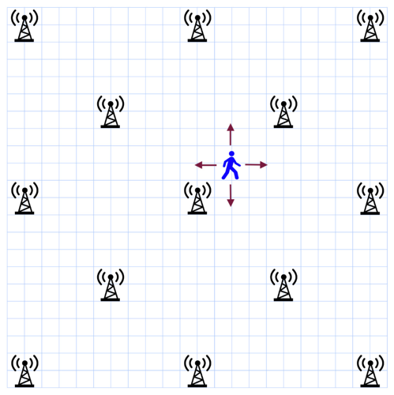

Figure 3: The structure of the map

## Base Station Allocation

## Due to the temporal variability of real-world cellular performance, which involves factors such as frequency band, resource block allocation, signal interference, backhaul load, and other variables, the experiment simplifies these complexities by introducing an "allocation" value as a proxy to represent the composite performance measured at the mobile device. Additionally, the experiment assumes that base station allocations are uniform and follow an isotropic radiation pattern in free space. To illustrate a scenario with significant allocation differences, allocation values of 5, 7 and 9 were utilized, as depicted in Figure 5.

## Handover/Handoff

## To define handovers, the mobile device initially checks for the three base stations with the highest Received Signal Strength Indicator (RSSI) based on their physical distance. After completing a random move, the MS evaluates whether there has been a change in the rank order of these strongest three signals. If there is no change, the MS remains in the same state and does not consider any mobility action. However, if the rank order changes and the strongest signal is also different

Then it knows that it is in a newer state, which means it will save it in its repository. Then, will perform handover once the connection is received and the device continues to move in the direction of the base station with the stronger signal(soft handover).

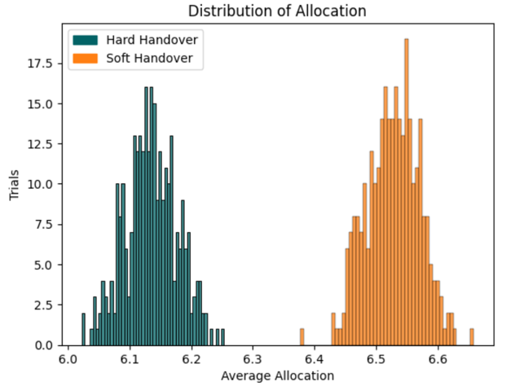

Figure 4: Distribution of Average Allocation Histogram

*D. Simulation Environment*

For the simulation we create an area that is a 45x45 unit grid containing 13 base stations placed at grid positions [0,0], [0,22], [0, 44], [22,0], [22,22], [22, 44], [44,0], [44,22], [44, 44], [11,11], [11,33], [33, 11], [33,33] (fig. 3). Each grid might represent a city block or a town block in Taiwan.

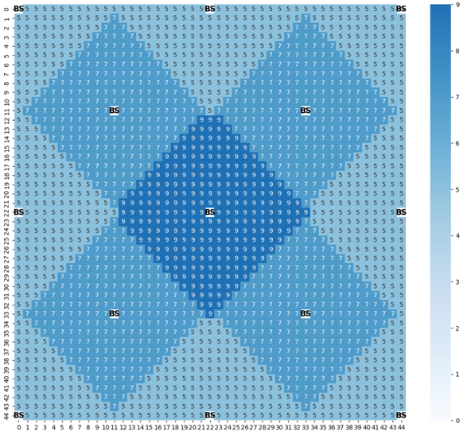

Figure 5: Average Allocation in Simulated Environment

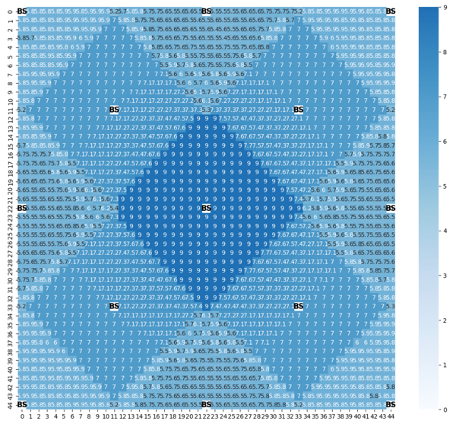

Figure 6: Average Allocation for Soft Handover in Simulated Environment

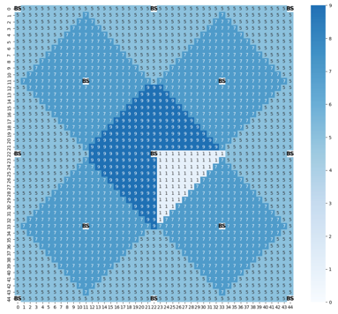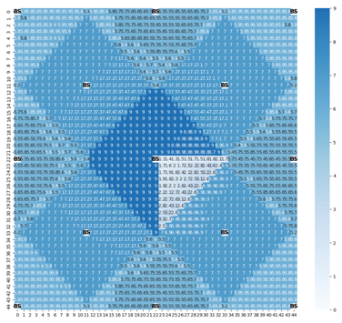

Figure 7: Average Allocation for Low Service Areas Activated

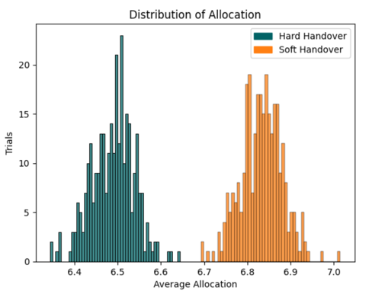

Figure 8: Distribution of Average Allocation for Low Service Area Activated Histogram



# Simulation Results and Future Trends

Our default result using hard transition is expected as we can see it chooses the closest base station and only connects to the base station in the area. Over around 300 trials, 15,000 walks with each walk having at most 10 steps, which is accumulatively 4,500,000 walks, we can see that the borders of the average allocation is extremely clear to which user it will connect to, no average dropoff in between. This is the most ideal scenario. Hard handoff allocation has a very clear distribution, as long as passing the board, handover occurs immediately.

For soft handovers, 44.33% of the total handover is override. Also, there are higher average allocation in areas bordering the higher allocation zone. Soft Handoff's average allocation is 5.92% higher than Hard Handoff.

In low service area soft handoff case, 42.52% of the the total handover is override. There are higher average allocation in areas bordering the higher allocation zone. Soft Handoff's average allocation is 6.21% higher than Hard Handoff.

Overriding those handovers indicates the amount of soft handoff that occurs. Because of this algorithm, unnecessary handoffs were don’t occur, and it detects when or when not to perform soft handoffs. This shift can be attributed to the learning process of the algorithm, where it acquires knowledge of handoffs involving the loaded base station areas and subsequently overrides the allocations based on that learned information.

One potential area for further investigation, building upon the presented results, is the impact and interaction of multiple mobile devices within the environment. It would be interesting to explore how these devices, all employing the algorithm, make mobility decisions and potentially shift network load. Such an investigation would bring the problem closer to existing experiments in reinforcement learning for wireless networks, enabling a meaningful comparison between the two approaches.

In summary, this paper provides early insights into the implications of mobile device handoff algorithm operation. The learning algorithm's ability to adapt to hidden environmental contexts and achieve improved results is notable. Further research can be conducted to examine the behavior of multiple MS using the algorithm.

##### 



##### References



1. “Handoff in Cellular Telecommunications.” *GeeksforGeeks*, 10 June 2023, www.geeksforgeeks.org/handoff-in-cellular-telecommunications/.
2. Carrascosa, Marc, and Boris Bellalta. “Decentralized AP Selection Using Multi-Armed Bandits: Opportunistic ε-Greedy with Stickiness.” *arXiv.Org*, 1 Mar. 2019, arxiv.org/abs/1903.00281.
3. Schiller, Jochen H. *Mobile Communications*. Addison-Wesley, 2003.
4. Suza Basloom, “Reducing Handoff Delay in SDN-Based 5G Networks Using AP Clustering.” *Procedia Computer Science*, 22 Jan. 2020, www.sciencedirect.com/science/article/pii/S1877050919321404.
5. *Handover between 5G and WLAN for Users Holding 5G Credential.*, www.researchgate.net/figure/Handover-between-5G-and-WLAN-for-users-holding-5G-credential_fig1_334640997. Accessed 22 June 2023.



1. Using Transition Learning to Enhance Mobile-Controlled Handoff In ..., arxiv.org/pdf/2202.00134.pdf. Accessed 22 June 2023.
2. Mei, Lifan, et al. “Realtime Mobile Bandwidth and Handoff Predictions in 4G/5G Networks.” *arXiv.Org*, 27 Apr. 2021, arxiv.org/abs/2104.12959.
3. *IEEE Xplore*, ieeexplore.ieee.org/Xplore/guesthome.jsp. Accessed 22 June 2023.
4. Mir, G. M., et al. “Decentralized Handoff for Microcellular Mobile Communication System Using Fuzzy Logic.” *Zenodo*, 23 Feb. 2009, zenodo.org/record/1331631.
5. Giannelli, Carlo. “Evaluating Filtering Strategies for Decentralized Handover Prediction in the Wireless Internet.” *11th IEEE Symposium on Computers and Communications (ISCC’06)*, 26 Mar. 2018, www.academia.edu/en/36263821/Evaluating_Filtering_Strategies_for_Decentralized_Handover_Prediction_in_the_Wireless_Internet.